

Experiment No.: 08

Title: Ansible
Batch: B–1 Roll No.: 16010422234 Experiment No.: 08
_____________________________________________________________________________

Aim: To write an Ansible playbook.
_____________________________________________________________________________

Resources needed: Killercoda (Online)
_____________________________________________________________________________

Theory:
Ansible provides open-source automation that reduces complexity and runs everywhere. Using Ansible lets you automate virtually any task. Here are some common use cases for Ansible:
- Eliminate repetition and simplify workflows
- Manage and maintain system configuration
- Continuously deploy complex software
- Perform zero-downtime rolling updates

Ansible uses simple, human-readable scripts called playbooks to automate your tasks. You declare the desired state of a local or remote system in your playbook. Ansible ensures that the system remains in that state.

Ansible is designed around the following principles:
Agent-less architecture
Low maintenance overhead by avoiding the installation of additional software across IT infrastructure.
Simplicity
Automation playbooks use straightforward YAML syntax for code that reads like documentation. Ansible is also decentralized, using SSH existing OS credentials to access to remote machines.
Scalability and flexibility
Easily and quickly scale the systems you automate through a modular design that supports a large range of operating systems, cloud platforms, and network devices.
Idempotence and predictability
When the system is in the state your playbook describes, Ansible does not change anything, even if the playbook runs multiple times.

Ansible Playbooks
Ansible Playbooks offer a repeatable, re-usable, simple configuration management and multi- machine deployment system, one that is well suited to deploying complex applications. If you need to execute a task with Ansible more than once, write a playbook and put it under source control. Then you can use the playbook to push out new configuration or confirm the configuration of remote systems. The playbooks in the Ansible-examples repository illustrate many useful techniques. You may want to look at these in another tab as you read the documentation.
_____________________________________________________________________________
Procedure:
- Install Ansible and create node-1, node-2, node-3 server. As shown in figure. https://killercoda.com/Ansible/scenario/Ansible-en-101
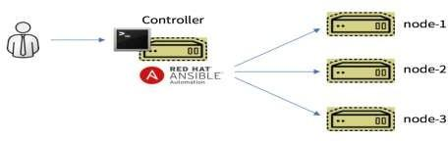
- Create your own playbook.
Figure 1 Ansible Automation
_____________________________________________________________________________

Results: (Document with screenshots)

- Steps with screenshots

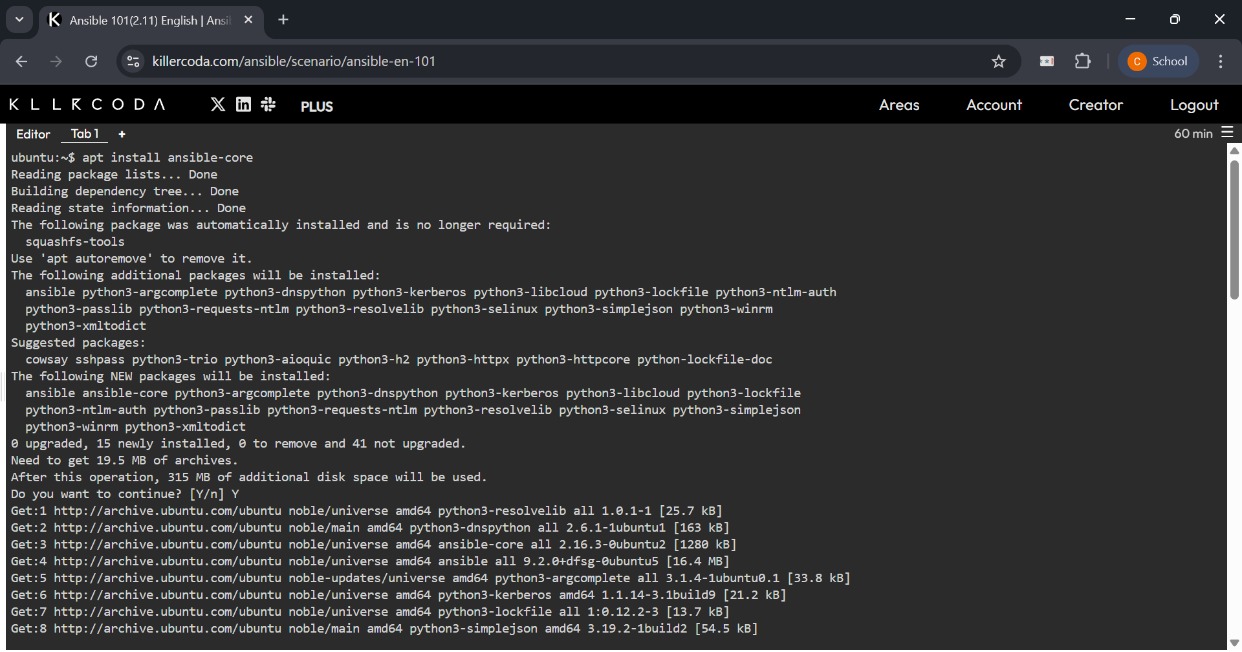
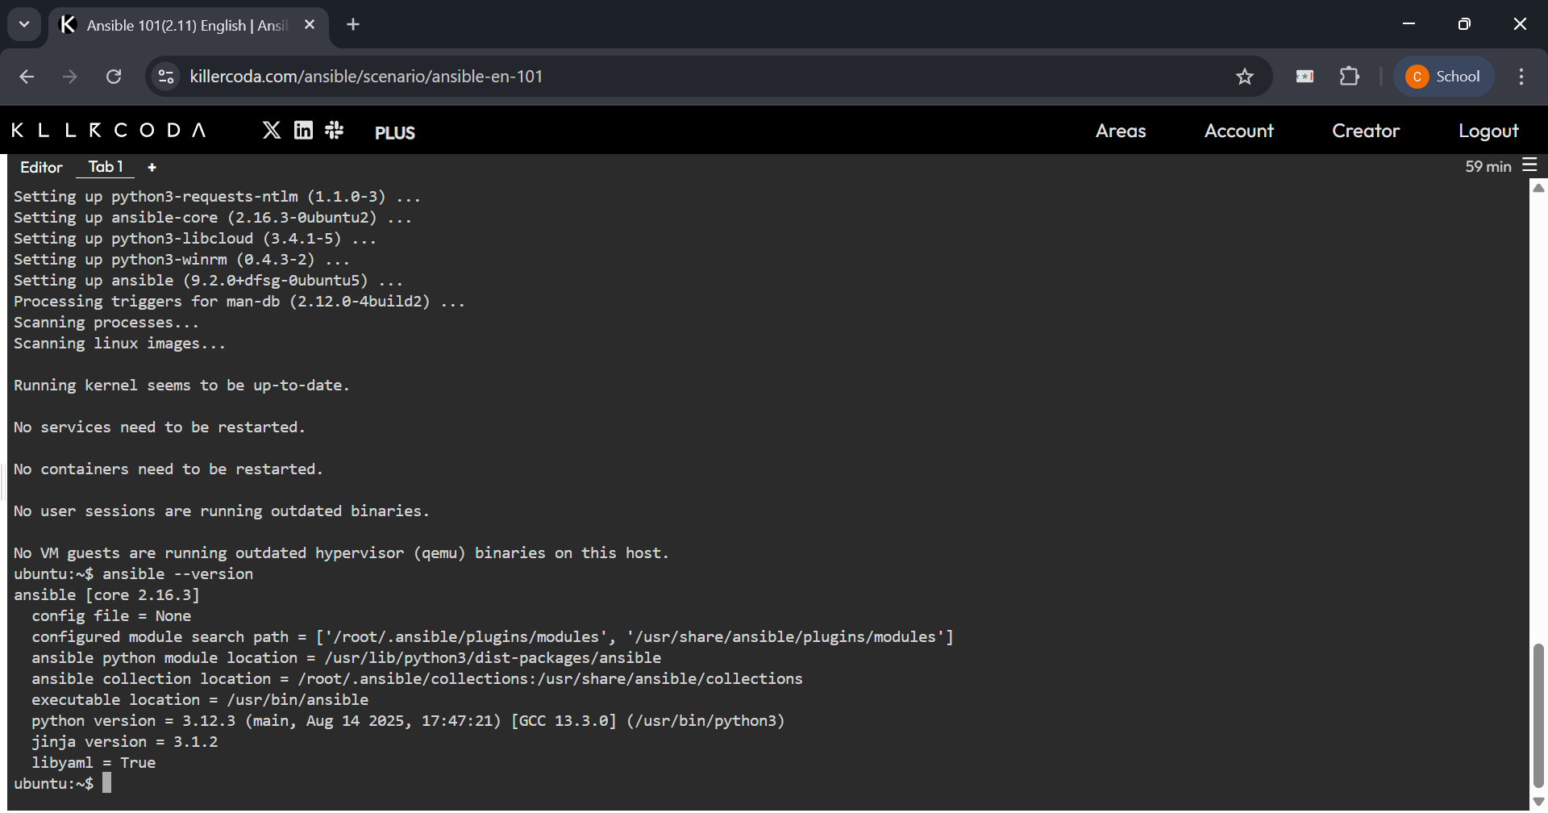

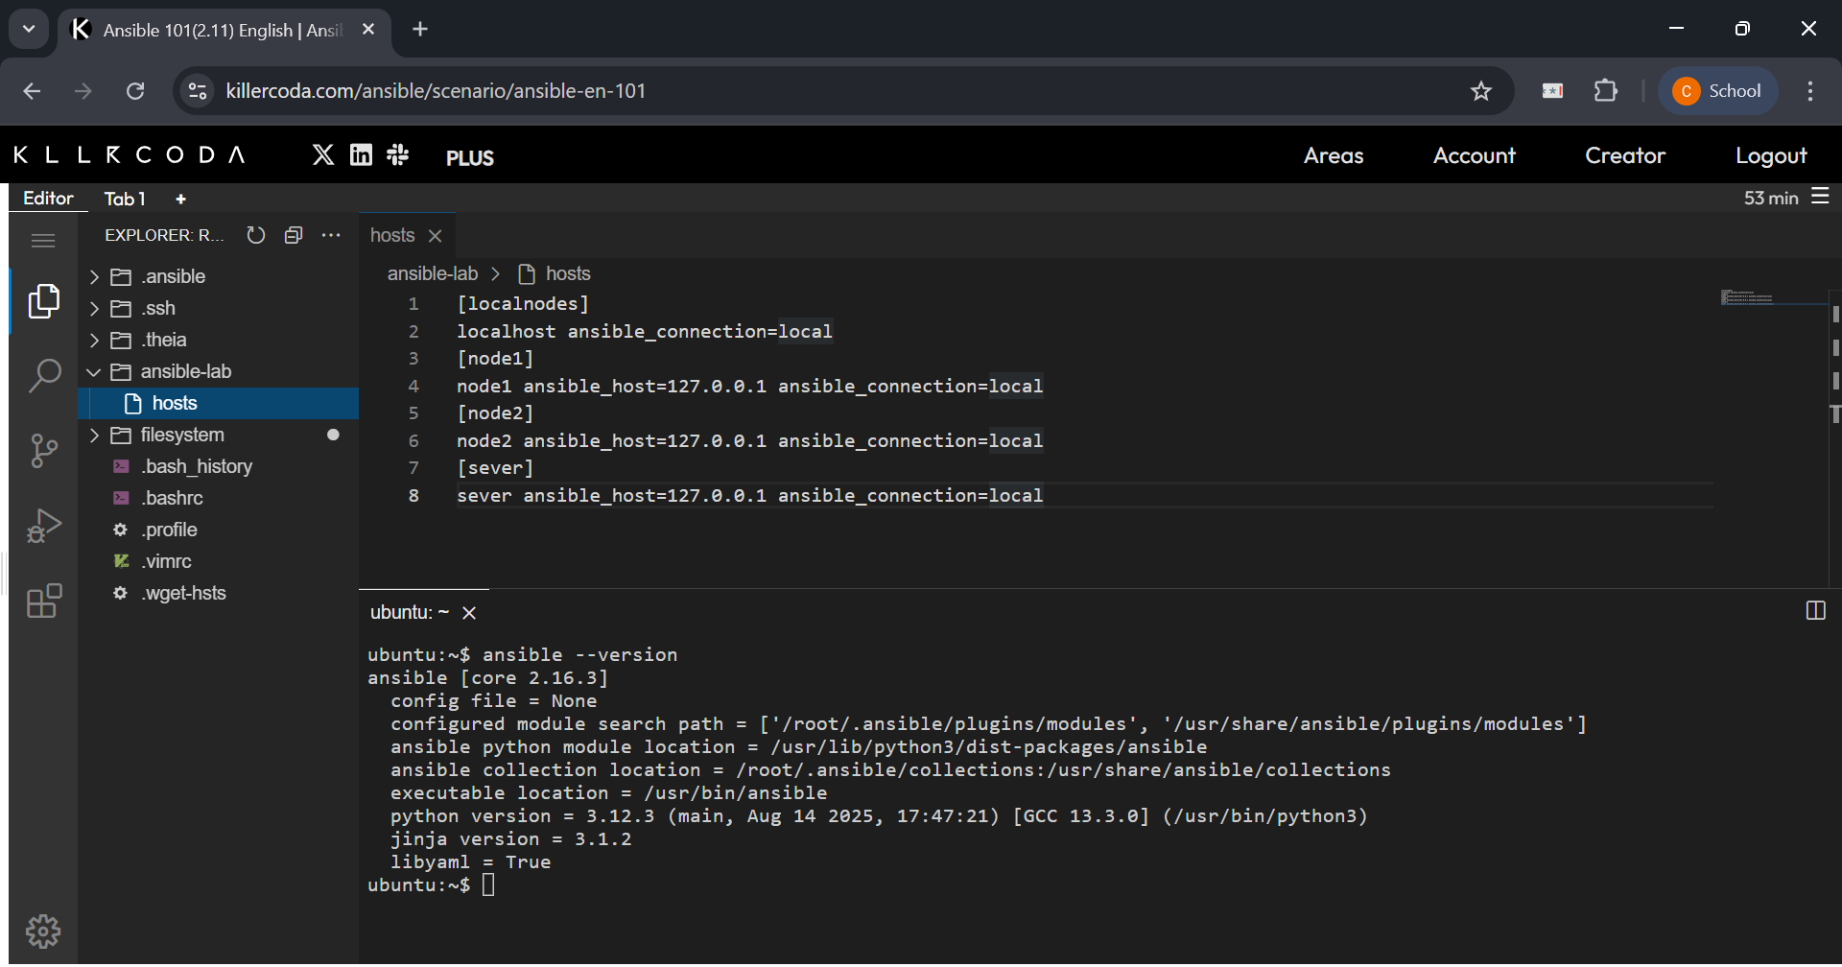
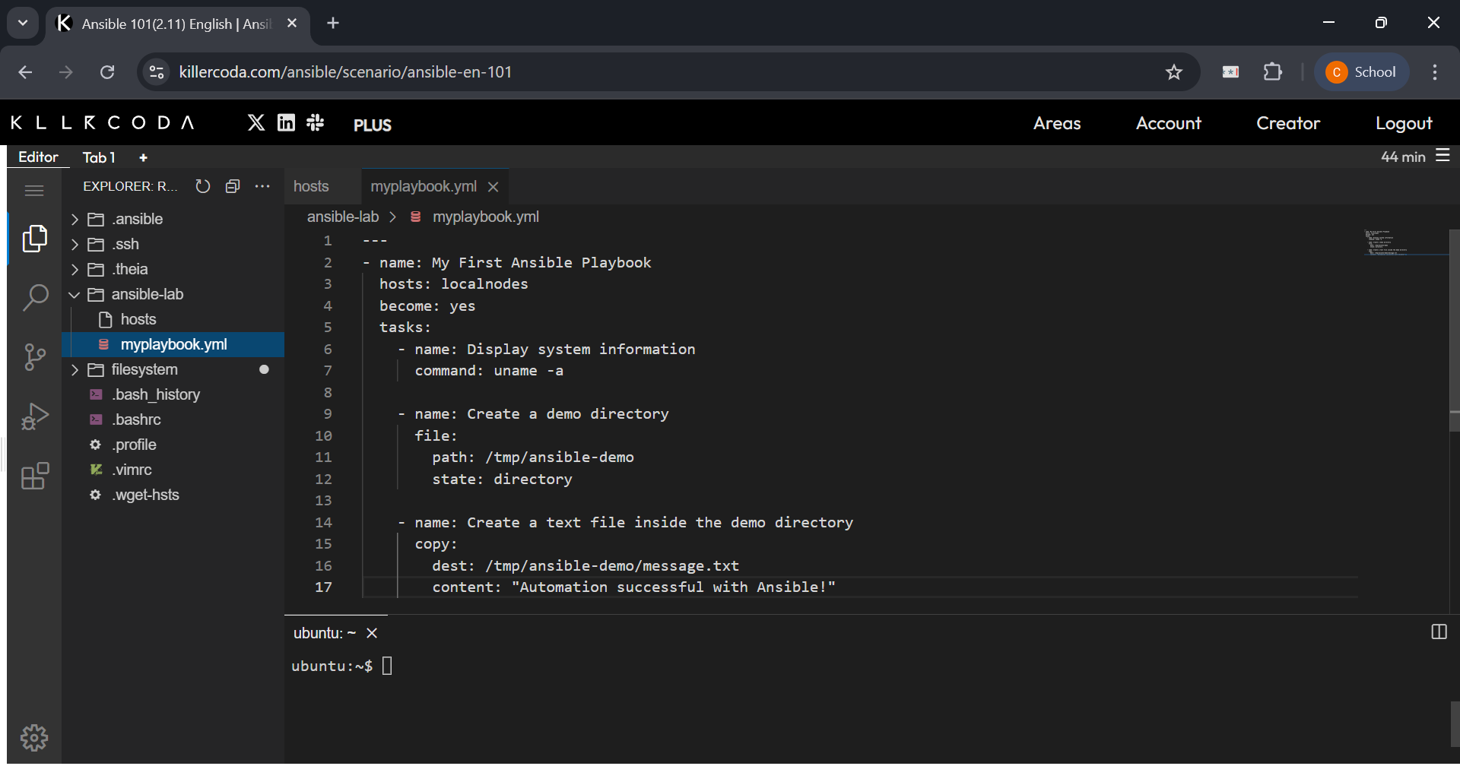

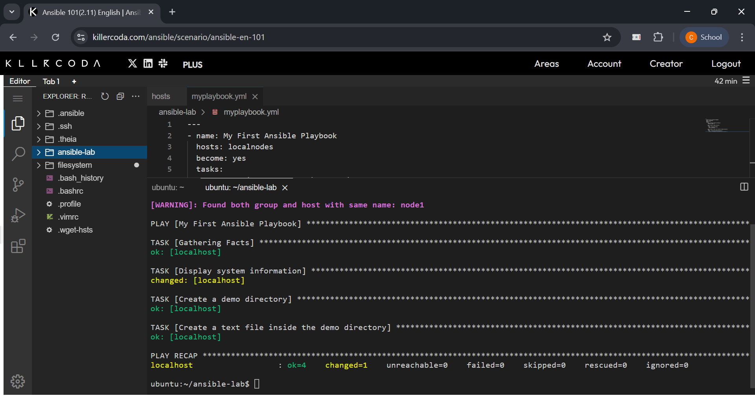
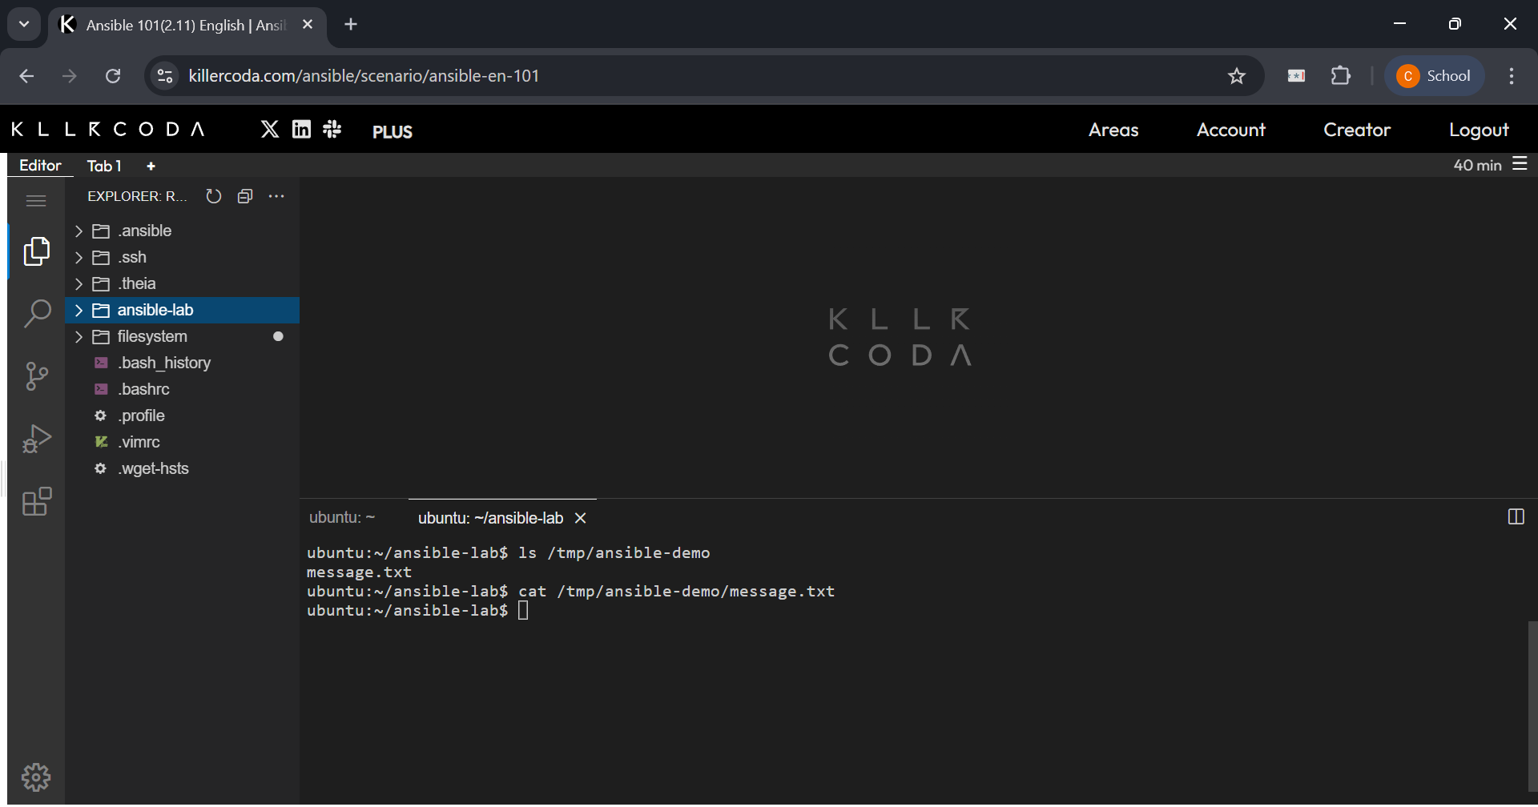
_____________________________________________________________________________

Questions:
- Difference between Ansible vs Puppet vs Chef.

Ans: Ansible, Puppet, and Chef are all popular open-source configuration management tools used for automating IT infrastructure. Here's a comparison:

Ansible:
- Architecture: Agent-less (uses SSH for communication).
- Configuration Language: YAML (Playbooks) - known for its simplicity and human-readability.
- Ease of Use: Generally considered the easiest to learn and set up due to its agent-less nature and simple YAML syntax.
- Scalability: Highly scalable, with Red Hat Ansible Automation Platform providing enterprise features for large environments.
- Management Model: Primarily push-based, where the control machine pushes configurations to the managed nodes.
- Written In: Python.

Puppet:
- Architecture: Agent-based (requires a Puppet agent on each managed node that communicates with a Puppet Master).
- Configuration Language: Puppet DSL (Domain-Specific Language) based on Ruby.
- Ease of Use: Relatively easier to learn than Chef but has a steeper learning curve than Ansible, requiring understanding of its DSL.
- Scalability: Designed for large-scale infrastructure management with a robust master-client architecture.
- Management Model: Primarily pull-based, where agents on the managed nodes pull configurations from the Puppet Master at regular intervals.
- Written In: Ruby.

Chef:
- Architecture: Agent-based (requires a Chef client on each node, communicating with a Chef server, with a workstation for development).
- Configuration Language: Ruby DSL (Cookbooks and Recipes) - requires programming skills in Ruby.
- Ease of Use: Has the steepest learning curve among the three due to its reliance on Ruby programming.
- Scalability: Highly scalable, transforming infrastructure into code for dynamic environments.
- Management Model: Primarily pull-based, with clients pulling configurations (cookbooks and recipes) from the Chef server.
- Written In: Ruby.

In summary, Ansible prioritizes simplicity and an agent-less approach, making it quick to deploy and easy to learn. Puppet and Chef are agent-based, offering more granular control and state management, but with higher complexity and a steeper learning curve, particularly Chef with its Ruby-centric approach.

- Explain agent less and agent base with examples.

Ans: The difference between agent-less and agent-based architectures lies in how the management system communicates with and controls the target machines.

Agent-less Architecture
- Definition: In an agent-less system, there is no specialized software or "agent" installed on the target machines (nodes) that are being managed. Instead, the central management server (control node) uses standard, pre-existing protocols to connect to and manage the remote systems.
- How it works: For Linux/Unix machines, Ansible typically uses SSH (Secure Shell) to connect, execute commands, and transfer files. For Windows machines, it might use WinRM (Windows Remote Management). These protocols are usually already present on the systems, eliminating the need for additional installations.
- Advantages:
  - Easier setup and maintenance: No agents to install, update, or troubleshoot on each managed node.
  - Reduced overhead: No extra processes running on the target systems, thus minimal impact on their performance.
  - Lower security risk: Fewer components to secure and fewer potential attack vectors.
- Disadvantages:
  - Dependency on existing protocols: Relies on SSH or WinRM being correctly configured and accessible.
  - Less real-time visibility: May not provide as granular or real-time monitoring data as agent-based systems, as it typically operates by pushing commands or pulling information at intervals.
- Example: Ansible is a prime example. An Ansible control node connects to target servers via SSH, executes tasks defined in playbooks, and ensures the desired state. There's no Ansible software daemon running permanently on the managed servers.

Agent-based Architecture
- Definition: In an agent-based system, a small piece of software, an "agent," is installed and runs continuously on each target machine that needs to be managed. This agent is responsible for collecting data, executing commands, and communicating with a central management server.
- How it works: The agent on each node periodically checks in with the central management server (e.g., Puppet Master, Chef Server) to receive configuration instructions or policies. It then applies these configurations to its host system and reports its status back to the server.
- Advantages:
  - Real-time monitoring and control: Agents can provide continuous, granular data and respond immediately to changes.
  - Offline operation: Some agents can store policies and continue to enforce them even if they temporarily lose connection to the central server.
  - Deeper insights: Can collect more detailed system-level information.
- Disadvantages:
  - Complex setup and maintenance: Requires installation, configuration, and ongoing updates of agents on every managed machine.
  - Resource consumption: Agents consume CPU, memory, and network resources on the target systems.
  - Potential security vulnerabilities: Each agent represents an additional attack surface.
- Examples: Puppet and Chef are classic examples. In Puppet, a "Puppet agent" runs on each client machine and communicates with the "Puppet Master." Similarly, in Chef, a "Chef client" runs on each node and pulls configuration instructions from the "Chef server" and Chef "cookbooks."
_____________________________________________________________________________

Outcomes: CO4 – Explain code deployment and monitoring systems and their tool support.
_____________________________________________________________________________

Conclusion: (Conclusion to be based on the Results and outcomes achieved)
This experiment aims to demonstrate the practical application of Ansible playbooks for automated IT infrastructure management. Ansible, with its agent-less architecture and simple YAML syntax, provides a highly scalable and flexible solution for configuration management and multi-machine deployment. Its idempotent nature ensures consistent system states, making it a powerful tool for deploying complex applications and maintaining system configurations efficiently. By automating tasks, Ansible significantly reduces manual overhead and promotes predictable IT operations.
_____________________________________________________________________________

Grade: AA / AB / BB / BC / CC / CD / DD

Signature of faculty in-charge with date
_____________________________________________________________________________

References:
Websites:
- Ansible Hello World: https://www.youtube.com/watch?v=vyiJrTHXE0M
- Use Ansible Playbooks:
https://docs.Ansible.com/Ansible/latest/playbook_guide/index.html
_____________________________________________________________________________

